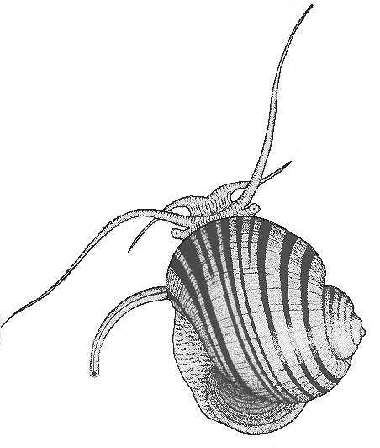
THE MALACOLOGICAL SOCIETY OF LONDON
Registered Charity No. 275980

Membership Secretary:-
Harriet Wood
Amgueddfa Cymru - Museum Wales
National Museum Cardiff
Cathays Park, Cardiff CF10 3NP

Email - membership@malacsoc.org.uk

Application form

TRAVEL AWARD

Application for the Broadening Access Membership Scheme (BAMS)
1. | Date of application:
2. | Details of applicant:
 | Full name: |  | Title:
 |  |  | Date of birth:
 | Current contact address: |  | Tel:
 |  |  | E-mail:
 | Current academic level of study: MSc / PhD / Other (please give details)
 | Mode of study: Full time / Part time
 | Start date: | Expected completion date:
 | Title of research course:
 | Address of research institution:
3. | How will you benefit from becoming a member of the The Malacological Society of London? (up to 200 words)
4. | Details of academic supervisor:
 | Name of course supervisor:
 | Supervisor’s e-mail:
 | Supervisor’s signature: Date:
 | Proof of course registration must be included for this application to be considered.
5. | Signature (applicant): Date:

