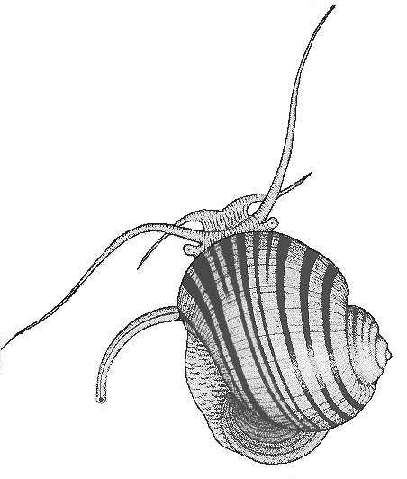
THE MALACOLOGICAL SOCIETY OF LONDON
Registered Charity No. 275980

Honorary Awards Secretary:-
Mr J. Ablett
Natural History Museum
London, SW7 5BD, UK

Email – MSL_awards@nhm.ac.uk

TRAVEL AWARDS

Guidance Notes

Travel Grant Guidance Notes

Travel Grants are available as bursaries to support attendance at a conference or workshop relevant to malacology. Grants are preferentially conferred on students but researchers without professional positions may also apply. The maximum amount for one of these awards is £500 for Society members and £300 for non-members; the Society anticipates that at least five awards will be made annually. NB: The December 2015 round is dedicated to travel to the 2016 UNITAS Congress in Malaysia and only applications to attend this meeting will be considered. For this round only, awards from the MSL will match those being offered by UNITAS (see details on their website: http://www.unitasmalacologica.org), which are equivalent to £600 for long-distance travel and £300 for shorter distances. Preference will be given to members of the Society; awards will be made at a reduced rate of £400 and £200 respectively to non-members. Note that while previous funding from the MSL does not exclude further applications, applications from applicants that have not yet received MSL funding may be treated preferentially.

Successful applications for Travel Awards that are concerned with the study of Bivalvia may be awarded as Sir Charles Maurice Yonge Awards.

The Society’s preferred method of payment is PayPal.

COMPLETION OF THE APPLICATION FORM:
When completing the form, a font size of at least 10 pt and Times New Roman or Arial font must be used.

Answer all questions. For question 4, please provide full details of the conference, meeting or workshop that you are seeking the Travel Award for. When giving a breakdown of the costs for the meeting (question 5), include full financial details in respect of your request (e.g. travel fares, accommodation and subsistence costs, or both). Note that poor breakdown of costs to be funded may result in decreased funding or disqualification of applications. If you have applied for, or received, other support for the meeting, list the source of the funds and give the amount secured or requested.

Your application should have the support of your project supervisor; please ask your supervisor to complete question 7 and sign and date the form. Please note that the supervisor’s comments make an important contribution to the decision making process and should provide sufficient detail about the applicant and the benefits expected from their travel. Note that it is your responsibility to ensure an email, if required, is provided by the supervisor. The Society will not contact supervisors on your behalf.

SUBMISSION OF YOUR APPLICATION
Please submit your signed and completed application by email to the Honorary Awards Secretary at MSL_awards@nhm.ac.uk, with “Travel Award Application” and your surname in the subject title. If you are unable to scan the file with your supervisor’s signature, please ask them to email their support to the Honorary Awards Secretary.

There are two annual closing dates for this scheme, 15th June and 15th December

CONDITIONS
Payment will be made after the date of travel. Recipients of Travel Awards will be asked to provide evidence of attendance at the event for which funding was sought and, when appropriate, are requested to acknowledge the financial support of the Society on posters or during oral presentations.

Any enquiries should be directed to the Honorary Awards Secretary.

